Cairo University  
Faculty of Computers and Artificial Intelligence



**CS251**

**Introduction to Software Engineering**



Software Design Specifications

Version 1.0

|  |  |
| --- | --- |
| **Name** | **Email** |
| Alan Samir Hakoun | [alanhakoun@gmail.com](mailto:alanhakoun@gmail.com) - 01006891062 |
| Sohaila Abdelazim Khalifa | [sohailakhalifa03@gmail.com](mailto:sohailakhalifa03@gmail.com) |
| Sara Tamer Mohamed Bihery | [sasooelbihery@gmail.com](mailto:sasooelbihery@gmail.com) |

April 2023

Contents

Team 3

Document Purpose and Audience 3

System Models 3

I. Architecture Diagram 3

II. Class Diagram(s) 7

III. Class Descriptions 8

IV. Sequence diagrams 10

Class - Sequence Usage Table 12

V. State Diagram 12

Tools 12

Ownership Report 12

# Team

|  |  |  |  |
| --- | --- | --- | --- |
| **ID** | **Name** | **Email** | **Mobile** |
| 20210755 | Alan Samir Hakoun | [alanhakoun@gmail.com](mailto:alanhakoun@gmail.com) | 01006891062 |
| 20210492 | Sohaila Abdelazim Khalifa | [Sohailakhalifa03@gmail.com](mailto:Sohailakhalifa03@gmail.com) | 01278489956 |
| 20210155 | Sara Tamer Mohamed Bihery | [sasooelbihery@gmail.com](mailto:sasooelbihery@gmail.com) | 01274239962 |

# Document Purpose and Audience

This document is meant to illustrate the Software Design Specifications such as the architecture, class, sequence and state designs. It outlines the technical details of the development of the software to help in implementing an accurate application depending on the requirements given earlier. Moreover, the document acts as a reference for the development team throughout the software development life cycle.

Audience:

• Project manager

• Software Development team [software architects, developers, testers]

• Stakeholders.

# System Models

## I. Architecture Diagram

Architecture used: C4 notation.   
Description: We used C4 architecture as its simple abstractions will make it easy to use as well as easy to understand, it gives details on what the system is, showing system components and the technologies used and who is going to use it, as well as what interacts with the database covering presentation, application and data tiers in a more detailed manner than 3-tier architecture.

Diagram:

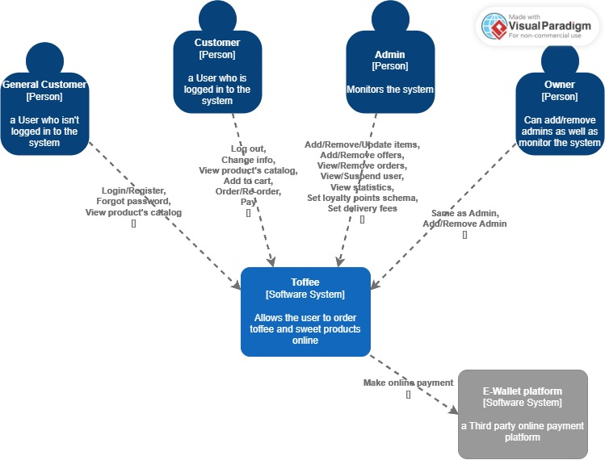  
**context:**

**Container:**

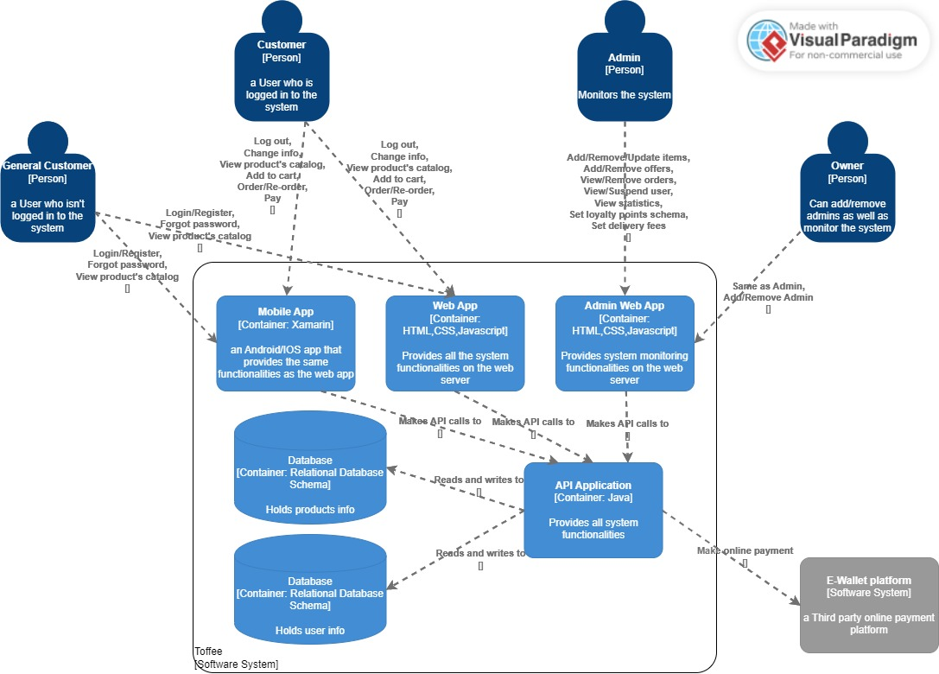

**Component:**

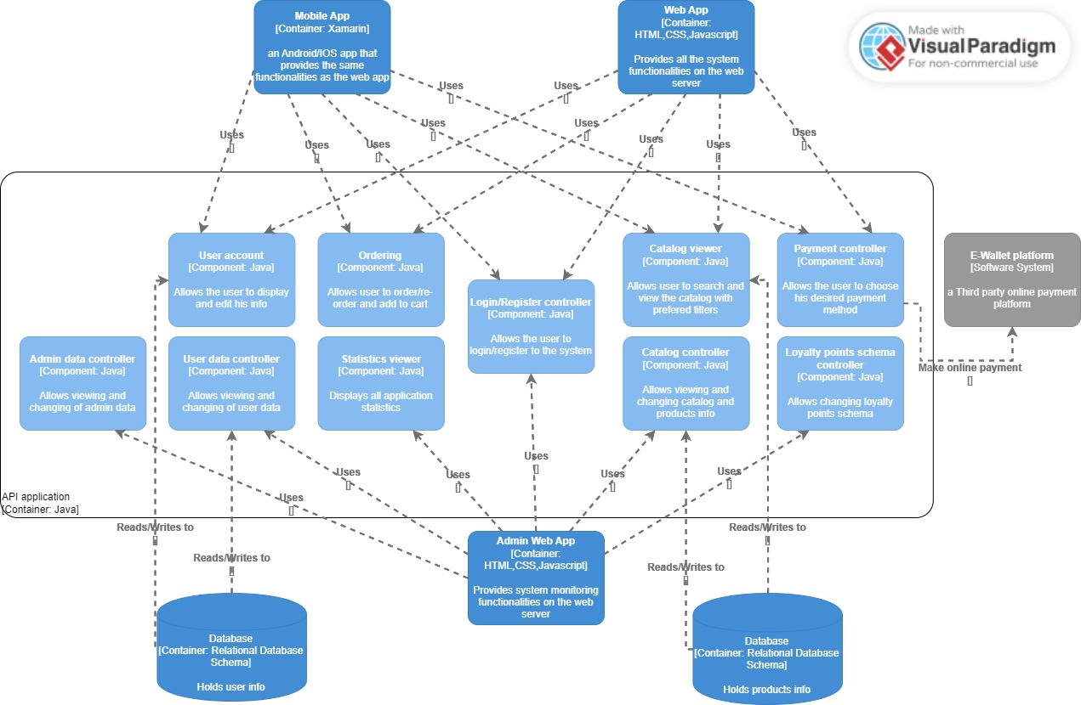

## II. Class Diagram(s)

## III. Class Descriptions

| **Class ID** | **Class Name** | **Description & Responsibility** |
| --- | --- | --- |
| 1. | SystemApp | Responsible for the management of the interface between the GUI of the application and its methods such as login and signup to access the features.in addition it has a relationship between the database class to be able to read and write user/system info. |
| 2. | Customer | Represents users who have created an account on the application, and therefore have access to additional features and methods such as making an order, adding to cart and editing their account info rather than just viewing the catalog. |
| 3. | Admin | It’s the class that includes all admin’s attributes and methods to allow him/her to control catalog, customers and track sales, the class has relationships with other classes as Order, Payment, and Catalog as admin can access each of them. |
| 4. | Owner | It’s an inherited class from Admin class, as the owner has all admin responsibilities and relationships in addition to some methods like tracking all admin and controlling each of them. |
| 5. | Order | It illustrates an order in the application. Each order has an id and contains information such as the ordered date and status. Also, it's one of the main classes as it has a relationship with classes such as cart to get info about the quantity and products ordered. |
| 6. | Cart | Represents the items that a customer has added to their cart while traversing the catalog but has not yet purchased. |
| 7. | OrderdProduct | Acts as a container that saves the product and its quantity to be ordered in cart. |
| 8. | Product | Contain the items that are available for purchase. As each product has a unique id, name, description, and price. |
| 9. | Catalog | Represents the collection of all products that are available for purchase in the application and stores data about them. |
| 10. | Payment | Shows the different methods of payment that are available to users when making an order. The Payment class is the abstract class of four inherited classes: Cash, LoyaltyPoints, Voucher, and EWallet. Each inherited class represents a specific method of payment that a user can use to complete the transaction. |
| 11. | Cash | Represents cash payments and its methods including verifying the phone number. |
| 12. | LoyaltyPoints | Represents methods that use loyalty points as the payment. |
| 13. | Voucher | Represents methods that use gift vouchers as payment. |
| 14. | EWallet | Represents payments made using a digital wallet redirecting to another platform. |
| 15. | GUI | Illustrates the class that deals with the UI interface of a customer and connects to application features. |
| 16. | AdminGUI | Illustrates the class that deals with the UI interface of an admin and connects to its application features. |
| 17. | UsersDatabase | Contains the database of the system including user info and data. |

## IV. Sequence diagrams

1.login :

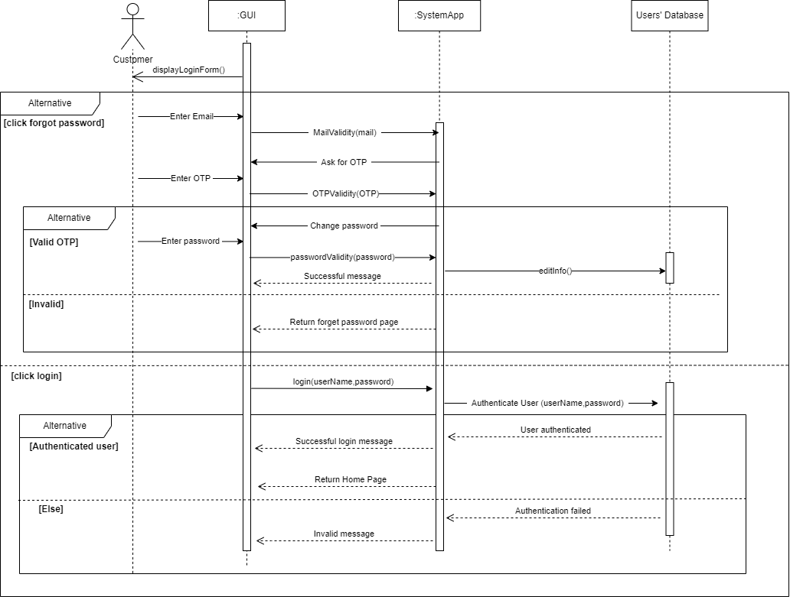

2.Register[signup]:

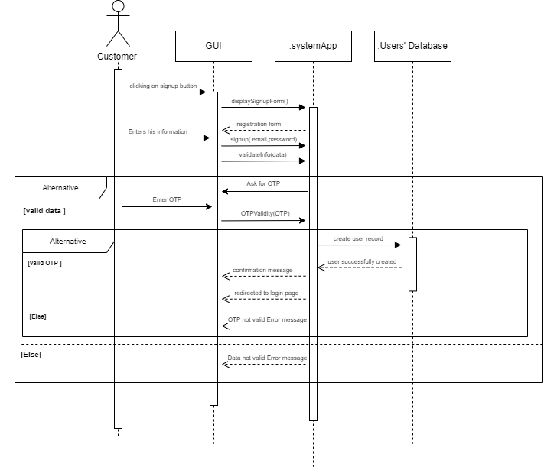

### Class - Sequence Usage Table

| **Sequence Diagram** | **Classes Used** | **All Methods Used** |
| --- | --- | --- |
| 1. Login | Class **systemApp**  Class **Users'Database** | Login  AuthenticateUser.  MailValidity  OTPValidity  PasswordValidity  EditInfo |
| 1. Register | Class **systemApp**  Class **Users'Database** | Signup  validateInfo  OTPValidity |

## V. State Diagram

# Tools

* **Draw.io - class diagram & sequence diagram.**
* **Visual paradigm - Architecture Diagram.**

# Ownership Report

|  |  |
| --- | --- |
| **Item** | **Owners** |
| Architecture Diagram, parts of class Diagram. | Alan Samir Hakoun |
| Sequence Diagram, parts of class Diagram. | Sohaila Abdelazim Khalifa |
| Sequence Diagram, parts of class Diagram. | Sara Tamer Mohamed |